UNITED STATES
SECURITIES AND EXCHANGE COMMISSION
Washington, D.C. 20549
FORM 8-K
CURRENT REPORT
Pursuant to Section 13 or 15(d) of the
Securities Exchange Act of 1934
Date of Report (Date of earliest event reported): September 1, 2026
BRADY CORPORATION
(Exact name of registrant as specified in its charter)
Commission File Number 1-14959
Wisconsin |  |  |  |  |  | 39-0178960
(State or other jurisdiction of incorporation or organization) |  |  |  |  |  | (IRS Employer Identification No.)
6555 West Good Hope Road
Milwaukee, Wisconsin 53223
(Address of Principal Executive Offices and Zip Code)
(414) 358-6600
(Registrant’s Telephone Number)
Check the appropriate box below if the Form 8-K filing is intended to simultaneously satisfy the filing obligation of the registrant under any of the following provisions:
☐ |  |  | Written communications pursuant to Rule 425 under the Securities Act (17 CFR 230.425)
☐ |  |  | Soliciting material pursuant to Rule 14a-12 under the Exchange Act (17 CFR 240.14a-12)
☐ |  |  | Pre-commencement communications pursuant to Rule 14d-2(b) under the Exchange Act (17 CFR 240.14d-2(b))
☐ |  |  | Pre-commencement communications pursuant to Rule 13e-4(c) under the Exchange Act (17 CFR 240.13e-4(c))
Securities registered pursuant to Section 12(b) of the Act:
Title of each class |  |  | Trading Symbol |  |  | Name of each exchange on which registered
Class A Nonvoting Common Stock, par value $0.01 per share |  |  | BRC |  |  | New York Stock Exchange
Indicate by check mark whether the registrant is an emerging growth company as defined in Rule 405 of the Securities Act of 1933 (§230.405 of this chapter) or Rule 12b-2 of the Securities Exchange Act of 1934 (§240.12b-2 of this chapter).
Emerging growth company ☐
If an emerging growth company, indicate by check mark if the registrant has elected not to use extended transition period for complying with any new or revised financial accounting standards provided pursuant to Section 13(a) of the Exchange Act. ☐

Item 2.02 |  |  | RESULTS OF OPERATIONS AND FINANCIAL CONDITION

On September 3, 2026, Brady Corporation (the “Company”) issued a press release announcing its fiscal 2026 fourth quarter financial results. A copy of the press release is being furnished to the Securities and Exchange Commission as Exhibit 99.1 attached hereto and is incorporated herein by reference.

Item 7.01 |  |  | REGULATION FD DISCLOSURE

On September 3, 2026, the Company hosted a conference call related to its fiscal 2026 fourth quarter financial results. A copy of the slides referenced in the conference call, which is also posted on the Company's website, is being furnished to the Securities and Exchange Commission as Exhibit 99.3 attached hereto and is incorporated herein by reference.

Item 8.01 |  |  | OTHER EVENTS

Increase in Annual Dividend
On September 1, 2026, the Company's Board of Directors approved an increase in the annual cash dividend on its Class A Common Stock from $0.98 to $1.00 per share. A quarterly dividend in the amount of $0.25 per share will be paid on October 30, 2026 to shareholders of record as of the close of business on October 9, 2026. A copy of the press release regarding the dividend is attached hereto as Exhibit 99.2 and is incorporated herein by reference.

Item 9.01 |  |  | FINANCIAL STATEMENTS AND EXHIBITS

(d) Exhibits
EXHIBIT NUMBER |  |  |  |  |  | DESCRIPTION
99.1 |  |  |  |  |  | Press Release of Brady Corporation, dated September 3, 2026, relating to fourth quarter fiscal 2026 financial results.
99.2 |  |  |  |  |  | Press Release of Brady Corporation, dated September 2, 2026, relating to increase in annual dividend.
99.3 |  |  |  |  |  | Informational slides provided by Brady Corporation, dated September 3, 2026, relating to fourth quarter fiscal 2026 financial results.
104 |  |  |  |  |  | Cover Page Interactive Data File (embedded within Inline XBRL document).

SIGNATURE
Pursuant to the requirements of the Securities Exchange Act of 1934, the Registrant has duly caused this report to be signed on its behalf by the undersigned hereunto duly authorized.

BRADY CORPORATION
Date: September 3, 2026
/s/ ANN E. THORNTON
Ann E. Thornton
Chief Financial Officer, Chief Accounting Officer and Treasurer

EXHIBIT 99.1

Brady Corporation Reports 2026 Fourth Quarter and Record Full Year Results

Achieved Record Annual Revenue and Adjusted Diluted Earnings Per Share
Completed Transformational Acquisition of Honeywell Technologies’ Productivity Solutions and Services Business on August 3, 2026
Announces Fiscal Year 2027 Guidance – Adjusted Diluted EPS Expected to Grow 23% at the Midpoint of Guidance Range

MILWAUKEE (September 3, 2026) -- Brady Corporation (NYSE: BRC) (“Brady” or “Company”), a world leader in identification, safety and productivity solutions, today announced its financial results for its fiscal 2026 fourth quarter and the year ended July 31, 2026.
“The results of the fourth quarter and full year 2026 are a clear indication of the momentum we are achieving at Brady Corporation,” said Vineet Nargolwala, President and Chief Executive Officer. “Our strong organic growth, with additional contributions from acquisitions and foreign currency translation, drove 10% sales growth for the quarter and the year. Organic sales growth and expanding margins drove a 15% increase in adjusted earnings per share in 2026 versus 2025.”
He continued, “As we enter 2027, continued growth in our Identification Solutions business (IDS), complemented by the addition of the newly named Intelligent Productivity Solutions business (IPS), is expected to drive 23% growth in adjusted diluted earnings per share* at the midpoint of our guidance range.”
Mr. Nargolwala concluded, “With the closing of the IPS acquisition, Brady becomes a stronger and more global industrial technology company. Our addressable market is expanding to $14 billion as we grow our presence in manufacturing, transportation, logistics, retail and healthcare markets. As we enter a new chapter for Brady, I could not be more excited about our opportunity to drive value for all of our stakeholders.”

Fourth Quarter Financial Results:
Sales for the quarter ended July 31, 2026 were $436.9 million, an increase of 10.0% compared to $397.3 million in the same quarter last year. The year-over-year increase was primarily driven by organic growth of 8.4%. By region, sales increased 13.5% in the Americas & Asia and 3.2% in Europe & Australia, primarily driven by organic sales growth of 11.6% in the Americas & Asia and 2.1% in Europe & Australia. See the Segment Information table for growth drivers and segment profit.
Income before income taxes decreased 8.2% to $55.6 million in the quarter ended July 31, 2026, compared to $60.5 million in the same quarter last year, reflecting acquisition and integration-related costs in the fourth quarter of 2026. Adjusted Income Before Income Taxes* was $89.0 million, an increase of 20.0% compared to $74.2 million in the fourth quarter of last year. See the GAAP to Non-GAAP Measures table for detailed adjustments.
Net income for the quarter was $45.6 million compared to $49.9 million in the same quarter last year, reflecting acquisition and integration-related costs in the fourth quarter of 2026. Adjusted Net Income* increased 17.5% to $70.7 million compared to $60.2 million in the same quarter last year. Earnings per diluted Class A Nonvoting Common Share was $0.96 compared to $1.04 in the same quarter last year. Adjusted Diluted EPS* was $1.48 compared to $1.26 in the same quarter last year, an increase of 17.5%.

Fiscal Year Financial Results:
Sales for the year ended July 31, 2026 increased 9.8% to $1.66 billion compared to $1.51 billion in the prior fiscal year. The year-over-year increase was primarily driven by organic growth of 5.3%. By region, sales increased 11.4% in the Americas & Asia and 6.7% in Europe & Australia, primarily driven by organic sales growth of 7.5% in the Americas & Asia and 1.2% in Europe & Australia.
Income before income taxes increased 9.4% to $259.4 million in the year ended July 31, 2026, compared to $237.1 million in the prior year. Adjusted Income Before Income Taxes* was $322.1 million, an increase of 15.2% compared to $279.5 million in 2025.
Net income was $205.4 million, an increase of 8.5% compared to $189.3 million last year. Adjusted Net Income* was $252.6 million, an increase of 14.2% compared to $221.3 million in 2025. Earnings per diluted Class A Nonvoting Common Share was $4.30, an increase of 9.1% compared to $3.94 in 2025. The company achieved record Adjusted Diluted EPS* of $5.29, a 15.0% increase compared to $4.60 in 2025.

Brady’s Chief Financial Officer, Ann Thornton, said, “We continued our strong momentum and achieved another annual adjusted earnings per share record, increased our cash flow from operating activities nearly 35% to $244.1 million in fiscal 2026 compared to $181.2 million in fiscal 2025, and returned $88.3 million to our shareholders in the form of dividends and share buybacks. Our net cash position of $172.2 million as of July 31, 2026, provided significant support for our acquisition of the Intelligent Productivity Solutions business. Our strong balance sheet allows us to continue to invest in organic growth, reduce our net leverage, and continue to return funds to our shareholders through dividends and share buybacks to drive long-term shareholder value.”

Fiscal 2027 Guidance:
The Company expects Adjusted Diluted EPS* for the year ending July 31, 2027 to range from $6.25 to $6.75 per share, which represents a range of growth of between 18.1 percent to 27.6 percent compared to 2026. The Company expects approximately $0.80 Adjusted Diluted EPS* accretion from the IPS segment, net of the cost of financing the transaction, with the majority of the contribution in the second half of the fiscal year as the business is integrated.
The Company expects revenue from the IDS segment to grow approximately 5 percent organically, and expects the IPS segment to contribute revenue of approximately $1.15 billion for the year ending July 31, 2027. Segment profit as a percentage of sales is expected to be approximately 20 percent within the IDS segment, and is expected to be in the low-double digits within the IPS segment.
Other elements of the Company’s 2027 guidance include depreciation expense of approximately $45 million, capital expenditures of approximately $40 million, and a full-year income tax rate of approximately 21 percent. Fiscal 2027 guidance is based upon foreign currency exchange rates as of July 31, 2026, and assumes continued economic growth.

A webcast regarding Brady’s fiscal 2026 fourth quarter financial results will be available at www.bradycorp.com/investors beginning at 7:30 a.m. central time today.

Brady Corporation (NYSE: BRC) is a global industrial technology company and a leading provider of identification, safety, and productivity solutions that help organizations of all sizes to identify, connect, protect,

track, and optimize what matters most. By combining trusted identification technologies with advanced data capture, enterprise mobility, software and workflow solutions, Brady’s comprehensive offerings enable its customers to improve safety, productivity, accuracy, and operational performance across their most critical functions and in the world’s most demanding environments. For more than 110 years, Brady has established trust and demonstrated its commitment to innovation, serving customers across manufacturing, logistics, healthcare, electronics, telecommunications, aerospace, construction, and other key industries, to make their work safer, smarter, and more connected. Headquartered in Milwaukee, Wisconsin, Brady employs approximately 9,300 people worldwide. Brady stock trades on the New York Stock Exchange under the symbol BRC. Learn more at www.bradycorp.com.

* Adjusted Income Before Income Taxes, Adjusted Net Income, and Adjusted Diluted EPS are non-GAAP measures. See appendix for more information on these measures, including reconciliations to the most directly comparable GAAP measures.

###

In this release, statements that are not reported financial results or other historic information are “forward-looking statements.” These forward-looking statements relate to, among other things, statements about the success of the acquisition, including anticipated benefits and synergies of the transaction, future opportunities for the combined company, and any other statements regarding the establishment of a new reporting segment for the IPS business, the combined company’s future operations and future financial position, anticipated economic activity, business strategies, targets, future earnings, anticipated growth, market opportunities, debt levels and cash flows, competition and other expectations and estimates for future periods including plans and objectives of management for future operations.

The use of words such as “may,” “will,” “expect,” “intend,” “estimate,” “anticipate,” “believe,” “should,” “project,” “plan” or similar terminology are generally intended to identify forward-looking statements. These forward-looking statements by their nature address matters that are, to different degrees, uncertain and are subject to risks, assumptions, and other factors, some of which are beyond the Company’s control, that could cause actual results to differ materially from those expressed or implied by such forward-looking statements. For the Company, uncertainties arise from: the ability of the Company and the IPS business to retain customers and retain and hire key personnel and maintain relationships with their suppliers and customers and on their operating results and businesses generally; potential difficulties integrating the IPS business, or the costs of integrating the IPS business exceeding original estimates; failure of the Company to achieve the anticipated benefits and synergies of the transaction identified in this release on the timeline indicated or at all; the establishment of a new reporting segment for the IPS business; increased cost of materials, labor, material shortages and supply chain disruptions, including as a result of tariffs or other impacts of the global trade environment; decreased demand for the Company’s products; the Company’s ability to compete effectively or to successfully execute our strategy; the Company’s ability to develop technologically advanced products that meet customer demands; the Company’s ability to identify, integrate and grow acquired companies, and to manage contingent liabilities from divested businesses; difficulties in protecting the Company’s websites, networks, and systems against security breaches; extensive regulations by U.S. and non-U.S. governmental and self-regulatory entities; risks associated with the loss of key employees; litigation, including product liability claims; global climate change and environmental regulations; foreign currency fluctuations; our indebtedness, financial condition and fulfillment of obligations thereunder; the ability to service our indebtedness; changes in tax legislation and tax rates; potential write-offs of goodwill and other intangible assets; differing interests of voting and non-voting shareholders and changes in the regulatory and business environment around dual-class voting structures; numerous other matters of national, regional and global scale, including major public health crises and government responses thereto and those of a political, economic, business, competitive, and regulatory nature contained from time to time in the Company’s U.S. Securities and Exchange Commission filings, including, but not limited to, those factors listed in the “Risk Factors” section within Item 1A of Part I of the Company’s Form 10-K for the year ended July 31, 2026.

These uncertainties may cause the Company’s actual future results to be materially different than those expressed in its forward-looking statements. The Company does not undertake to update its forward-looking statements except as required by law.

BRADY CORPORATION AND SUBSIDIARIES
CONSOLIDATED STATEMENTS OF INCOME
(Unaudited; Dollars in thousands, except per share data)
 |  |  | Three months ended July 31, |  |  |  |  |  |  |  |  |  |  |  | Year ended July 31,
 |  |  | 2026 |  |  |  |  |  | 2025 |  |  |  |  |  | 2026 |  |  |  |  |  | 2025
Net sales |  |  | $ | 436,904 |  |  |  |  | $ | 397,275 |  |  |  |  | $ | 1,661,565 |  |  |  |  | $ | 1,513,605
Cost of goods sold |  |  | 205,770 |  |  |  |  |  | 197,044 |  |  |  |  |  | 801,736 |  |  |  |  |  | 752,783
Gross margin |  |  | 231,134 |  |  |  |  |  | 200,231 |  |  |  |  |  | 859,829 |  |  |  |  |  | 760,822
Operating expenses:
Research and development |  |  | 22,899 |  |  |  |  |  | 23,054 |  |  |  |  |  | 94,031 |  |  |  |  |  | 79,889
Selling, general and administrative |  |  | 148,117 |  |  |  |  |  | 117,885 |  |  |  |  |  | 502,312 |  |  |  |  |  | 444,295
Total operating expenses |  |  | 171,016 |  |  |  |  |  | 140,939 |  |  |  |  |  | 596,343 |  |  |  |  |  | 524,184
Operating income |  |  | 60,118 |  |  |  |  |  | 59,292 |  |  |  |  |  | 263,486 |  |  |  |  |  | 236,638
Other income (expense):
Investment and other income |  |  | 1,680 |  |  |  |  |  | 2,356 |  |  |  |  |  | 5,628 |  |  |  |  |  | 5,206
Interest expense |  |  | (6,232) |  |  |  |  |  | (1,143) |  |  |  |  |  | (9,699) |  |  |  |  |  | (4,747)
Income before income taxes |  |  | 55,566 |  |  |  |  |  | 60,505 |  |  |  |  |  | 259,415 |  |  |  |  |  | 237,097
Income tax expense |  |  | 9,975 |  |  |  |  |  | 10,629 |  |  |  |  |  | 54,037 |  |  |  |  |  | 47,841
Net income |  |  | $ | 45,591 |  |  |  |  | $ | 49,876 |  |  |  |  | $ | 205,378 |  |  |  |  | $ | 189,256
Net income per Class A Nonvoting Common Share:
Basic |  |  | $ | 0.97 |  |  |  |  | $ | 1.05 |  |  |  |  | $ | 4.34 |  |  |  |  | $ | 3.97
Diluted |  |  | $ | 0.96 |  |  |  |  | $ | 1.04 |  |  |  |  | $ | 4.30 |  |  |  |  | $ | 3.94
Net income per Class B Voting Common Share:
Basic |  |  | $ | 0.97 |  |  |  |  | $ | 1.05 |  |  |  |  | $ | 4.33 |  |  |  |  | $ | 3.96
Diluted |  |  | $ | 0.96 |  |  |  |  | $ | 1.04 |  |  |  |  | $ | 4.29 |  |  |  |  | $ | 3.92
Weighted average common shares outstanding:
Basic |  |  | 47,200 |  |  |  |  |  | 47,335 |  |  |  |  |  | 47,285 |  |  |  |  |  | 47,641
Diluted |  |  | 47,716 |  |  |  |  |  | 47,780 |  |  |  |  |  | 47,750 |  |  |  |  |  | 48,092

BRADY CORPORATION AND SUBSIDIARIES
CONSOLIDATED BALANCE SHEETS
(Dollars in thousands)
 |  |  | July 31, 2026 |  |  |  |  |  | July 31, 2025
ASSETS
Current assets:
Cash and cash equivalents |  |  | $ | 187,149 |  |  |  |  | $ | 174,349
Accounts receivable, net of allowance for credit losses of $7,742 and $7,876, respectively |  |  | 260,938 |  |  |  |  |  | 231,944
Inventories |  |  | 225,214 |  |  |  |  |  | 200,881
Prepaid expenses and other current assets |  |  | 15,231 |  |  |  |  |  | 14,661
Total current assets |  |  | 688,532 |  |  |  |  |  | 621,835
Property, plant and equipment—net |  |  | 254,460 |  |  |  |  |  | 225,572
Goodwill |  |  | 685,968 |  |  |  |  |  | 676,945
Other intangible assets |  |  | 97,833 |  |  |  |  |  | 105,374
Deferred income taxes |  |  | 21,126 |  |  |  |  |  | 20,862
Operating lease assets |  |  | 67,916 |  |  |  |  |  | 58,422
Other assets |  |  | 36,114 |  |  |  |  |  | 25,243
Total |  |  | $ | 1,851,949 |  |  |  |  | $ | 1,734,253
LIABILITIES AND STOCKHOLDERS’ EQUITY
Current liabilities:
Accounts payable |  |  | $ | 108,703 |  |  |  |  | $ | 105,028
Accrued compensation and benefits |  |  | 105,777 |  |  |  |  |  | 92,657
Taxes, other than income taxes |  |  | 22,161 |  |  |  |  |  | 21,537
Accrued income taxes |  |  | 7,443 |  |  |  |  |  | 5,547
Current operating lease liabilities |  |  | 17,020 |  |  |  |  |  | 15,234
Other current liabilities |  |  | 94,399 |  |  |  |  |  | 90,329
Total current liabilities |  |  | 355,503 |  |  |  |  |  | 330,332
Long-term debt |  |  | 14,985 |  |  |  |  |  | 99,766
Long-term operating lease liabilities |  |  | 51,588 |  |  |  |  |  | 43,565
Other liabilities |  |  | 72,311 |  |  |  |  |  | 68,379
Total liabilities |  |  | 494,387 |  |  |  |  |  | 542,042
Stockholders’ equity:
Common stock:
Class A nonvoting common stock — Issued 51,261,487 shares, and outstanding 43,360,586 and 43,530,012 shares, respectively |  |  | 513 |  |  |  |  |  | 513
Class B voting common stock — Issued and outstanding 3,538,628 shares |  |  | 35 |  |  |  |  |  | 35
Additional paid-in capital |  |  | 374,456 |  |  |  |  |  | 359,269
Retained earnings |  |  | 1,476,978 |  |  |  |  |  | 1,317,739
Treasury stock — 7,900,901 and 7,731,475 shares, respectively, of Class A nonvoting common stock, at cost |  |  | (419,618) |  |  |  |  |  | (393,186)
Accumulated other comprehensive loss |  |  | (74,802) |  |  |  |  |  | (92,159)
Total stockholders’ equity |  |  | 1,357,562 |  |  |  |  |  | 1,192,211
Total |  |  | $ | 1,851,949 |  |  |  |  | $ | 1,734,253

BRADY CORPORATION AND SUBSIDIARIES
CONSOLIDATED STATEMENTS OF CASH FLOWS
(Unaudited; Dollars in thousands)
 |  |  | Year ended July 31,
 |  |  | 2026 |  |  |  |  |  | 2025
Operating activities:
Net income |  |  | $ | 205,378 |  |  |  |  | $ | 189,256
Adjustments to reconcile net income to net cash provided by operating activities:
Depreciation and amortization |  |  | 44,870 |  |  |  |  |  | 40,639
Stock-based compensation expense |  |  | 22,855 |  |  |  |  |  | 11,882
Deferred income taxes |  |  | 2,361 |  |  |  |  |  | (7,623)
Other |  |  | (1,675) |  |  |  |  |  | (2,540)
Changes in operating assets and liabilities (net of effects of business acquisitions):
Accounts receivable |  |  | (24,074) |  |  |  |  |  | (14,356)
Inventories |  |  | (19,183) |  |  |  |  |  | (18,889)
Prepaid expenses and other assets |  |  | (1,369) |  |  |  |  |  | (2,098)
Accounts payable and accrued liabilities |  |  | 13,208 |  |  |  |  |  | (9,862)
Income taxes |  |  | 1,756 |  |  |  |  |  | (5,213)
Net cash provided by operating activities |  |  | 244,127 |  |  |  |  |  | 181,196
Investing activities:
Purchases of property, plant and equipment |  |  | (51,473) |  |  |  |  |  | (27,577)
Acquisition of businesses, net of cash acquired |  |  | (17,416) |  |  |  |  |  | (144,541)
Other |  |  | 9,873 |  |  |  |  |  | 864
Net cash used in investing activities |  |  | (59,016) |  |  |  |  |  | (171,254)
Financing activities:
Payment of dividends |  |  | (46,139) |  |  |  |  |  | (45,542)
Proceeds from exercise of stock options |  |  | 11,318 |  |  |  |  |  | 6,171
Payments for employee taxes withheld from stock-based awards |  |  | (3,345) |  |  |  |  |  | (2,683)
Purchase of treasury stock |  |  | (42,204) |  |  |  |  |  | (50,838)
Proceeds from borrowing on credit facilities |  |  | 69,500 |  |  |  |  |  | 266,846
Repayment of borrowing on credit facilities |  |  | (154,281) |  |  |  |  |  | (258,015)
Other |  |  | (12,220) |  |  |  |  |  | 190
Net cash used in financing activities |  |  | (177,371) |  |  |  |  |  | (83,871)
Effect of exchange rate changes on cash and cash equivalents |  |  | 5,060 |  |  |  |  |  | (1,840)
Net increase (decrease) in cash and cash equivalents |  |  | 12,800 |  |  |  |  |  | (75,769)
Cash and cash equivalents, beginning of period |  |  | 174,349 |  |  |  |  |  | 250,118
Cash and cash equivalents, end of period |  |  | $ | 187,149 |  |  |  |  | $ | 174,349
Supplemental disclosures of cash flow information:
Cash interest paid |  |  | $ | 2,858 |  |  |  |  | $ | 4,656

BRADY CORPORATION AND SUBSIDIARIES
SEGMENT INFORMATION
(Unaudited; Dollars in thousands)
 |  |  | Three months ended July 31, |  |  |  |  |  |  |  |  |  |  |  | Year ended July 31,
 |  |  | 2026 |  |  |  |  |  | 2025 |  |  |  |  |  | 2026 |  |  |  |  |  | 2025
NET SALES
Americas & Asia |  |  | $ | 296,068 |  |  |  |  | $ | 260,789 |  |  |  |  | $ | 1,106,620 |  |  |  |  | $ | 993,715
Europe & Australia |  |  | 140,836 |  |  |  |  |  | 136,486 |  |  |  |  |  | 554,945 |  |  |  |  |  | 519,890
Total |  |  | $ | 436,904 |  |  |  |  | $ | 397,275 |  |  |  |  | $ | 1,661,565 |  |  |  |  | $ | 1,513,605
SALES INFORMATION
Americas & Asia
Organic |  |  | 11.6 |  | % |  |  |  | 4.3 |  | % |  |  |  | 7.5 |  | % |  |  |  | 4.8 |  | %
Acquisitions |  |  | 1.7 |  | % |  |  |  | 9.8 |  | % |  |  |  | 3.3 |  | % |  |  |  | 8.3 |  | %
Currency |  |  | 0.2 |  | % |  |  |  | — |  | % |  |  |  | 0.6 |  | % |  |  |  | (0.6) |  | %
Divestiture |  |  | — |  | % |  |  |  | — |  | % |  |  |  | — |  | % |  |  |  | (0.4) |  | %
Total |  |  | 13.5 |  | % |  |  |  | 14.1 |  | % |  |  |  | 11.4 |  | % |  |  |  | 12.1 |  | %
Europe & Australia
Organic |  |  | 2.1 |  | % |  |  |  | (1.3) |  | % |  |  |  | 1.2 |  | % |  |  |  | (1.8) |  | %
Acquisitions |  |  | — |  | % |  |  |  | 14.4 |  | % |  |  |  | — |  | % |  |  |  | 14.7 |  | %
Currency |  |  | 1.1 |  | % |  |  |  | 5.7 |  | % |  |  |  | 5.5 |  | % |  |  |  | 1.4 |  | %
Total |  |  | 3.2 |  | % |  |  |  | 18.8 |  | % |  |  |  | 6.7 |  | % |  |  |  | 14.3 |  | %
Total Company
Organic |  |  | 8.4 |  | % |  |  |  | 2.4 |  | % |  |  |  | 5.3 |  | % |  |  |  | 2.6 |  | %
Acquisitions |  |  | 1.1 |  | % |  |  |  | 11.3 |  | % |  |  |  | 2.2 |  | % |  |  |  | 10.5 |  | %
Currency |  |  | 0.5 |  | % |  |  |  | 2.0 |  | % |  |  |  | 2.3 |  | % |  |  |  | — |  | %
Divestiture |  |  | — |  | % |  |  |  | — |  | % |  |  |  | — |  | % |  |  |  | (0.3) |  | %
Total |  |  | 10.0 |  | % |  |  |  | 15.7 |  | % |  |  |  | 9.8 |  | % |  |  |  | 12.8 |  | %
SEGMENT PROFIT
Americas & Asia |  |  | $ | 74,271 |  |  |  |  | $ | 51,617 |  |  |  |  | $ | 256,615 |  |  |  |  | $ | 209,765
Europe & Australia |  |  | 18,677 |  |  |  |  |  | 15,070 |  |  |  |  |  | 74,301 |  |  |  |  |  | 56,942
Total |  |  | $ | 92,948 |  |  |  |  | $ | 66,687 |  |  |  |  | $ | 330,916 |  |  |  |  | $ | 266,707
SEGMENT PROFIT AS A PERCENT OF NET SALES
Americas & Asia |  |  | 25.1 |  | % |  |  |  | 19.8 |  | % |  |  |  | 23.2 |  | % |  |  |  | 21.1 |  | %
Europe & Australia |  |  | 13.3 |  | % |  |  |  | 11.0 |  | % |  |  |  | 13.4 |  | % |  |  |  | 11.0 |  | %
Total |  |  | 21.3 |  | % |  |  |  | 16.8 |  | % |  |  |  | 19.9 |  | % |  |  |  | 17.6 |  | %
 |  |  | Three months ended July 31, |  |  |  |  |  |  |  |  |  |  |  | Year ended July 31,
 |  |  | 2026 |  |  |  |  |  | 2025 |  |  |  |  |  | 2026 |  |  |  |  |  | 2025
Total segment profit |  |  | $ | 92,948 |  |  |  |  | $ | 66,687 |  |  |  |  | $ | 330,916 |  |  |  |  | $ | 266,707
Unallocated amounts:
Administrative costs |  |  | (32,830) |  |  |  |  |  | (7,395) |  |  |  |  |  | (67,430) |  |  |  |  |  | (30,069)
Investment and other income |  |  | 1,680 |  |  |  |  |  | 2,356 |  |  |  |  |  | 5,628 |  |  |  |  |  | 5,206
Interest expense |  |  | (6,232) |  |  |  |  |  | (1,143) |  |  |  |  |  | (9,699) |  |  |  |  |  | (4,747)
Income before income taxes |  |  | $ | 55,566 |  |  |  |  | $ | 60,505 |  |  |  |  | $ | 259,415 |  |  |  |  | $ | 237,097

GAAP to NON-GAAP MEASURES
(Unaudited; Dollars in Thousands, Except Per Share Amounts)
In accordance with the U.S. Securities and Exchange Commission’s Regulation G, the following provides definitions of the non-GAAP measures used in the earnings release and the reconciliation to the most closely related GAAP measure.
Adjusted Income Before Income Taxes:
Brady is presenting the non-GAAP measure, “Adjusted Income Before Income Taxes.” This is not a calculation based upon GAAP. The amounts included in this non-GAAP measure are derived from amounts included in the Consolidated Financial Statements and supporting footnote disclosures. We do not view these items to be part of our ongoing results. We believe this profit measure provides an important perspective of underlying business trends and results and provides a more comparable measure from year to year. The table below provides a reconciliation of the GAAP measure of Income before income taxes to the non-GAAP measure of Adjusted Income Before Income Taxes:
 |  |  | Three months ended July 31, |  |  |  |  |  |  |  |  |  |  |  | Year ended July 31,
 |  |  | 2026 |  |  |  |  |  | 2025 |  |  |  |  |  | 2026 |  |  |  |  |  | 2025
Income before income taxes (GAAP measure) |  |  | $ | 55,566 |  |  |  |  | $ | 60,505 |  |  |  |  | $ | 259,415 |  |  |  |  | $ | 237,097
Amortization expense |  |  | 5,151 |  |  |  |  |  | 4,778 |  |  |  |  |  | 20,919 |  |  |  |  |  | 18,916
Non-recurring acquisitions-related costs and other related expenses (1) |  |  | 22,241 |  |  |  |  |  | — |  |  |  |  |  | 35,747 |  |  |  |  |  | 5,059
Executive transition costs |  |  | 6,051 |  |  |  |  |  | — |  |  |  |  |  | 6,051 |  |  |  |  |  | —
Facility closure and other reorganization costs |  |  | — |  |  |  |  |  | 8,890 |  |  |  |  |  | — |  |  |  |  |  | 18,474
Adjusted Income Before Income Taxes (non-GAAP measure) |  |  | $ | 89,009 |  |  |  |  | $ | 74,173 |  |  |  |  | $ | 322,132 |  |  |  |  | $ | 279,546
(1)Non-recurring acquisition-related costs and other related expenses includes third party integration support, financing fees, legal and other administrative expenses.

Adjusted Income Tax Expense:
Brady is presenting the non-GAAP measure, “Adjusted Income Tax Expense.” This is not a calculation based upon GAAP. The amounts included in this non-GAAP measure are derived from amounts included in the Consolidated Financial Statements and supporting footnote disclosures. We do not view these items to be part of our ongoing results. We believe this measure provides an important perspective of underlying business trends and results and provides a more comparable measure from year to year. The table below provides a reconciliation of the GAAP measure of Income tax expense to the non-GAAP measure of Adjusted Income Tax Expense:
 |  |  | Three months ended July 31, |  |  |  |  |  |  |  |  |  |  |  | Year ended July 31,
 |  |  | 2026 |  |  |  |  |  | 2025 |  |  |  |  |  | 2026 |  |  |  |  |  | 2025
Income tax expense (GAAP measure) |  |  | $ | 9,975 |  |  |  |  | $ | 10,629 |  |  |  |  | $ | 54,037 |  |  |  |  | $ | 47,841
Amortization expense |  |  | 1,247 |  |  |  |  |  | 1,148 |  |  |  |  |  | 5,050 |  |  |  |  |  | 4,550
Non-recurring acquisitions-related costs and other related expenses (1) |  |  | 5,561 |  |  |  |  |  | — |  |  |  |  |  | 8,937 |  |  |  |  |  | 1,265
Executive transition costs |  |  | 1,513 |  |  |  |  |  | — |  |  |  |  |  | 1,513 |  |  |  |  |  | —
Facility closure and other reorganization costs |  |  | — |  |  |  |  |  | 2,222 |  |  |  |  |  | — |  |  |  |  |  | 4,618
Adjusted Income Tax Expense (non-GAAP measure) |  |  | $ | 18,296 |  |  |  |  | $ | 13,999 |  |  |  |  | $ | 69,537 |  |  |  |  | $ | 58,274

Adjusted Net Income:
Brady is presenting the non-GAAP measure, “Adjusted Net Income.” This is not a calculation based upon GAAP. The amounts included in this non-GAAP measure are derived from amounts included in the Consolidated Financial Statements and supporting footnote disclosures. We do not view these items to be part of our ongoing results. We believe this measure provides an important perspective of underlying business trends and results and provides a more comparable measure from year to year. The table below provides a reconciliation of the GAAP measure of Net income to the non-GAAP measure of Adjusted Net Income:
 |  |  | Three months ended July 31, |  |  |  |  |  |  |  |  |  |  |  | Year ended July 31,
 |  |  | 2026 |  |  |  |  |  | 2025 |  |  |  |  |  | 2026 |  |  |  |  |  | 2025
Net income (GAAP measure) |  |  | $ | 45,591 |  |  |  |  | $ | 49,876 |  |  |  |  | $ | 205,378 |  |  |  |  | $ | 189,256
Amortization expense |  |  | 3,904 |  |  |  |  |  | 3,630 |  |  |  |  |  | 15,869 |  |  |  |  |  | 14,366
Non-recurring acquisitions-related costs and other related expenses (1) |  |  | 16,680 |  |  |  |  |  | — |  |  |  |  |  | 26,810 |  |  |  |  |  | 3,794
Executive transition costs |  |  | 4,538 |  |  |  |  |  | — |  |  |  |  |  | 4,538 |  |  |  |  |  | —
Facility closure and other reorganization costs |  |  | — |  |  |  |  |  | 6,668 |  |  |  |  |  | — |  |  |  |  |  | 13,856
Adjusted Net Income (non-GAAP measure) |  |  | $ | 70,713 |  |  |  |  | $ | 60,174 |  |  |  |  | $ | 252,595 |  |  |  |  | $ | 221,272

Adjusted Diluted EPS:
Brady is presenting the non-GAAP measure, “Adjusted Diluted EPS.” This is not a calculation based upon GAAP. The amounts included in this non-GAAP measure are derived from amounts included in the Consolidated Financial Statements. We do not view these items to be part of our ongoing results. We believe this measure provides an important perspective of underlying business trends and results and provides a more comparable measure from year to year. The table below provides a reconciliation of the GAAP measure of Net income per Class A Nonvoting Common Share to the non-GAAP measure of Adjusted Diluted EPS (Note that certain amounts will not foot due to rounding):
 |  |  | Three months ended July 31, |  |  |  |  |  |  |  |  |  |  |  | Year ended July 31,
 |  |  | 2026 |  |  |  |  |  | 2025 |  |  |  |  |  | 2026 |  |  |  |  |  | 2025
Net income per Class A Nonvoting Common Share (GAAP measure) |  |  | $ | 0.96 |  |  |  |  | $ | 1.04 |  |  |  |  | $ | 4.30 |  |  |  |  | $ | 3.94
Amortization expense |  |  | 0.08 |  |  |  |  |  | 0.08 |  |  |  |  |  | 0.33 |  |  |  |  |  | 0.30
Non-recurring acquisitions-related costs and other related expenses (1) |  |  | 0.35 |  |  |  |  |  | — |  |  |  |  |  | 0.56 |  |  |  |  |  | 0.08
Executive transition costs |  |  | 0.10 |  |  |  |  |  | — |  |  |  |  |  | 0.10 |  |  |  |  |  | —
Facility closure and other reorganization costs |  |  | — |  |  |  |  |  | 0.14 |  |  |  |  |  | — |  |  |  |  |  | 0.29
Adjusted Diluted EPS (non-GAAP measure) |  |  | $ | 1.48 |  |  |  |  | $ | 1.26 |  |  |  |  | $ | 5.29 |  |  |  |  | $ | 4.60

EXHIBIT 99.2

For More Information Contact:
Investor Contact: Ann Thornton 414 438-6887
Media Contact: Kate Venne 414 358-5176

Brady Corporation increases its dividend to shareholders for the 41st consecutive year

MILWAUKEE (September 2, 2026) -- On September 1, 2026, Brady Corporation’s (NYSE: BRC) Board of Directors approved an increase in the annual dividend to shareholders of the Company’s Class A Common Stock from $0.98 per share to $1.00 per share. A quarterly dividend to shareholders of the Company’s Class A Common Stock of $0.25 per share will be paid on October 30, 2026, to shareholders of record at the close of business on October 9, 2026. This dividend represents the 41st consecutive annual increase in dividends.
Brady Corporation (NYSE: BRC) is a global industrial technology company and a leading provider of identification, safety, and productivity solutions that help organizations of all sizes to identify, connect, protect, track, and optimize what matters most. By combining trusted identification technologies with advanced data capture, enterprise mobility, software and workflow solutions, Brady’s comprehensive offerings enable its customers to improve safety, productivity, accuracy, and operational performance across their most critical functions and in the world’s most demanding environments. For more than 110 years, Brady has established trust and demonstrated its commitment to innovation, serving customers across manufacturing, logistics, healthcare, electronics, telecommunications, aerospace, construction, and other key industries, to make their work safer, smarter, and more connected. Headquartered in Milwaukee, Wisconsin, Brady employs approximately 9,300 people worldwide. Brady stock trades on the New York Stock Exchange under the symbol BRC. Learn more at www.bradycorp.com.

###



September 3, 2026 Q4 and Year-end Financial Results F’26

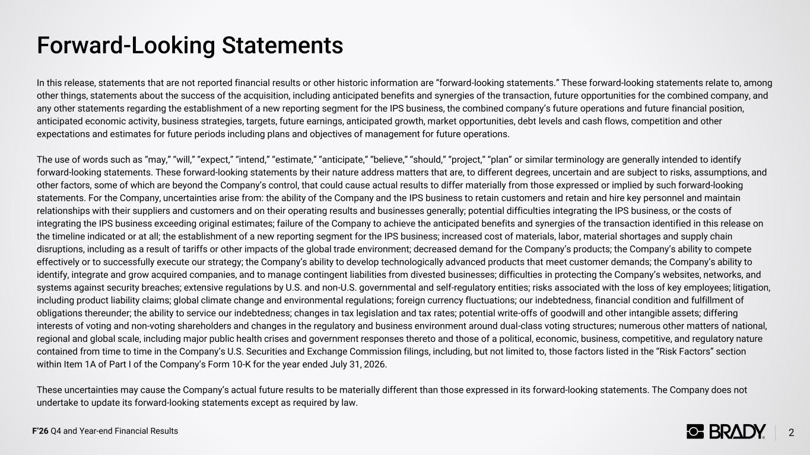
F’26 Q4 and Year-end Financial Results Forward-Looking Statements In this release, statements that are not reported financial results or other historic information are “forward-looking statements.” These forward-looking statements relate to, among other things, statements about the success of the acquisition, including anticipated benefits and synergies of the transaction, future opportunities for the combined company, and any other statements regarding the establishment of a new reporting segment for the IPS business, the combined company’s future operations and future financial position, anticipated economic activity, business strategies, targets, future earnings, anticipated growth, market opportunities, debt levels and cash flows, competition and other expectations and estimates for future periods including plans and objectives of management for future operations. The use of words such as “may,” “will,” “expect,” “intend,” “estimate,” “anticipate,” “believe,” “should,” “project,” “plan” or similar terminology are generally intended to identify forward-looking statements. These forward-looking statements by their nature address matters that are, to different degrees, uncertain and are subject to risks, assumptions, and other factors, some of which are beyond the Company’s control, that could cause actual results to differ materially from those expressed or implied by such forward-looking statements. For the Company, uncertainties arise from: the ability of the Company and the IPS business to retain customers and retain and hire key personnel and maintain relationships with their suppliers and customers and on their operating results and businesses generally; potential difficulties integrating the IPS business, or the costs of integrating the IPS business exceeding original estimates; failure of the Company to achieve the anticipated benefits and synergies of the transaction identified in this release on the timeline indicated or at all; the establishment of a new reporting segment for the IPS business; increased cost of materials, labor, material shortages and supply chain disruptions, including as a result of tariffs or other impacts of the global trade environment; decreased demand for the Company’s products; the Company’s ability to compete effectively or to successfully execute our strategy; the Company’s ability to develop technologically advanced products that meet customer demands; the Company’s ability to identify, integrate and grow acquired companies, and to manage contingent liabilities from divested businesses; difficulties in protecting the Company’s websites, networks, and systems against security breaches; extensive regulations by U.S. and non-U.S. governmental and self-regulatory entities; risks associated with the loss of key employees; litigation, including product liability claims; global climate change and environmental regulations; foreign currency fluctuations; our indebtedness, financial condition and fulfillment of obligations thereunder; the ability to service our indebtedness; changes in tax legislation and tax rates; potential write-offs of goodwill and other intangible assets; differing interests of voting and non-voting shareholders and changes in the regulatory and business environment around dual-class voting structures; numerous other matters of national, regional and global scale, including major public health crises and government responses thereto and those of a political, economic, business, competitive, and regulatory nature contained from time to time in the Company’s U.S. Securities and Exchange Commission filings, including, but not limited to, those factors listed in the “Risk Factors” section within Item 1A of Part I of the Company’s Form 10-K for the year ended July 31, 2026. These uncertainties may cause the Company’s actual future results to be materially different than those expressed in its forward-looking statements. The Company does not undertake to update its forward-looking statements except as required by law. 2

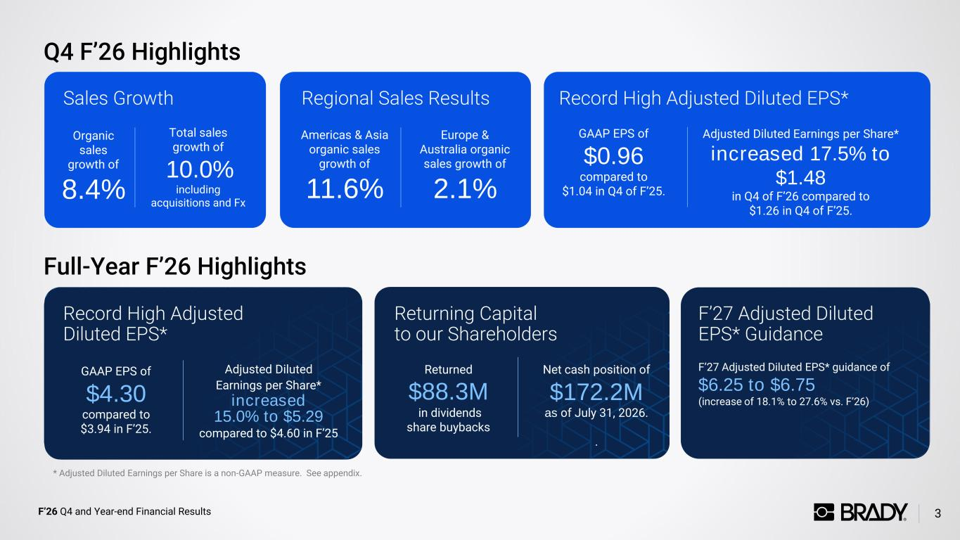
F’26 Q4 and Year-end Financial Results Q4 F’26 Highlights 3 Sales Growth Record High Adjusted Diluted EPS* Returning Capital to our Shareholders Organic sales growth of 8.4% Total sales growth of 10.0% including acquisitions and Fx GAAP EPS of $4.30 compared to $3.94 in F’25. Adjusted Diluted Earnings per Share* increased 15.0% to $5.29 compared to $4.60 in F’25 Returned $88.3M in dividends share buybacks Net cash position of $172.2M as of July 31, 2026. . Record High Adjusted Diluted EPS*Regional Sales Results Americas & Asia organic sales growth of 11.6% Europe & Australia organic sales growth of 2.1% GAAP EPS of $0.96 compared to $1.04 in Q4 of F’25. Adjusted Diluted Earnings per Share* increased 17.5% to $1.48 in Q4 of F’26 compared to $1.26 in Q4 of F’25. * Adjusted Diluted Earnings per Share is a non-GAAP measure. See appendix. F’27 Adjusted Diluted EPS* Guidance F’27 Adjusted Diluted EPS* guidance of $6.25 to $6.75 (increase of 18.1% to 27.6% vs. F’26) Full-Year F’26 Highlights

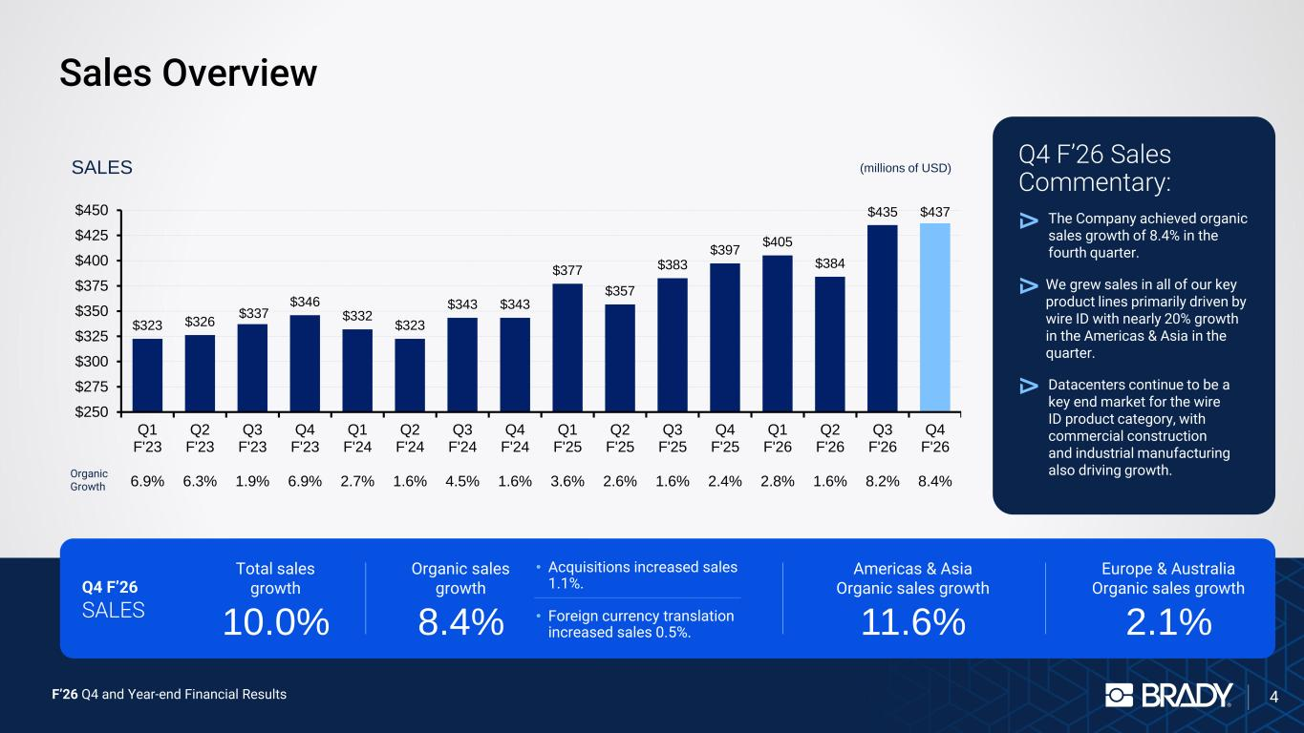
F’26 Q4 and Year-end Financial Results Sales Overview 4 Q4 F’26 Sales Commentary: We grew sales in all of our key product lines primarily driven by wire ID with nearly 20% growth in the Americas & Asia in the quarter. The Company achieved organic sales growth of 8.4% in the fourth quarter. Datacenters continue to be a key end market for the wire ID product category, with commercial construction and industrial manufacturing also driving growth. Total sales growth 10.0% Organic sales growth 8.4% • Acquisitions increased sales 1.1%. • Foreign currency translation increased sales 0.5%. Americas & Asia Organic sales growth 11.6% Europe & Australia Organic sales growth 2.1% $323 $326 $337 $346 $332 $323 $343 $343 $377 $357 $383 $397 $405 $384 $435 $437 $250 $275 $300 $325 $350 $375 $400 $425 $450 Q1 F'23 6.9% Q2 F'23 6.3% Q3 F'23 1.9% Q4 F'23 6.9% Q1 F'24 2.7% Q2 F'24 1.6% Q3 F'24 4.5% Q4 F'24 1.6% Q1 F'25 3.6% Q2 F'25 2.6% Q3 F'25 1.6% Q4 F'25 2.4% Q1 F'26 2.8% Q2 F'26 1.6% Q3 F'26 8.2% Q4 F'26 8.4% Organic Growth SALES (millions of USD) Q4 F’26 SALES

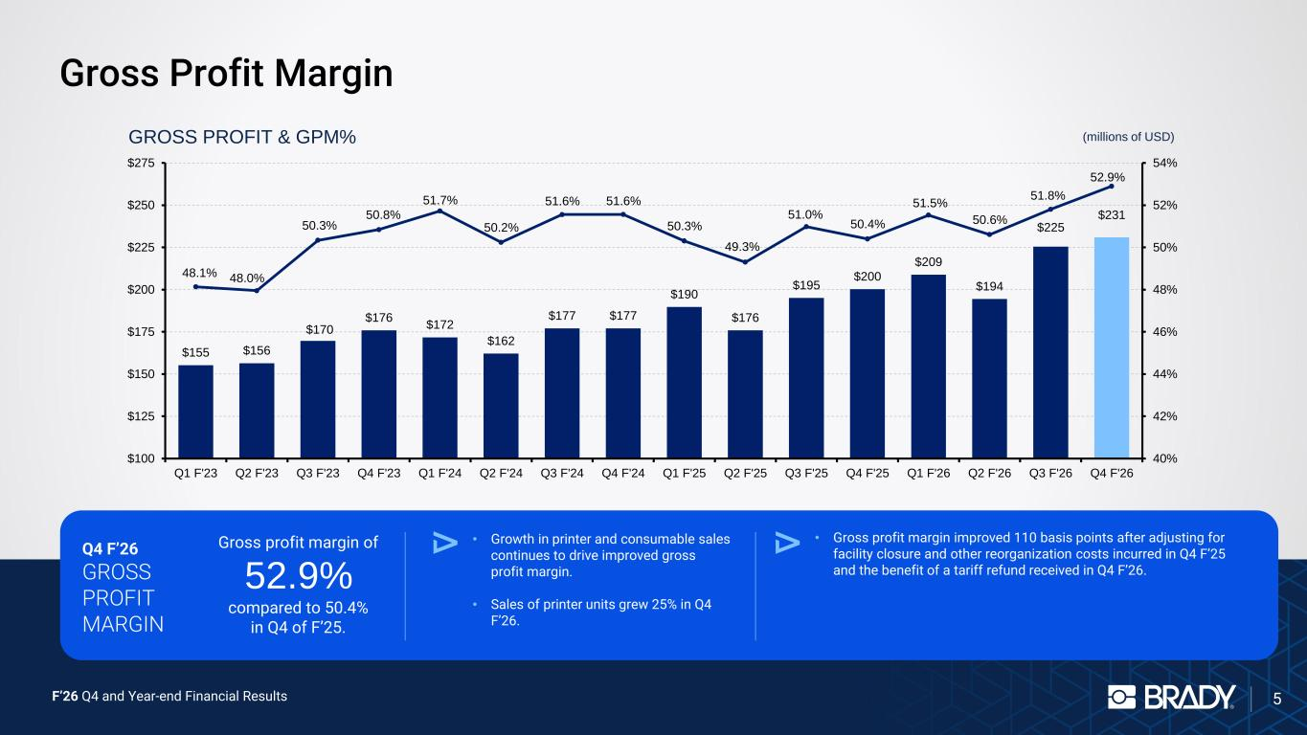
F’26 Q4 and Year-end Financial Results Gross Profit Margin 5 Gross profit margin of 52.9% compared to 50.4% in Q4 of F’25. • Growth in printer and consumable sales continues to drive improved gross profit margin. • Sales of printer units grew 25% in Q4 F’26. $155 $156 $170 $176 $172 $162 $177 $177 $190 $176 $195 $200 $209 $194 $225 $231 48.1% 48.0% 50.3% 50.8% 51.7% 50.2% 51.6% 51.6% 50.3% 49.3% 51.0% 50.4% 51.5% 50.6% 51.8% 52.9% 40% 42% 44% 46% 48% 50% 52% 54% $100 $125 $150 $175 $200 $225 $250 $275 Q1 F'23 Q2 F'23 Q3 F'23 Q4 F'23 Q1 F'24 Q2 F'24 Q3 F'24 Q4 F'24 Q1 F'25 Q2 F'25 Q3 F'25 Q4 F'25 Q1 F'26 Q2 F'26 Q3 F'26 Q4 F'26 GROSS PROFIT & GPM% (millions of USD) • Gross profit margin improved 110 basis points after adjusting for facility closure and other reorganization costs incurred in Q4 F’25 and the benefit of a tariff refund received in Q4 F’26. Q4 F’26 GROSS PROFIT MARGIN

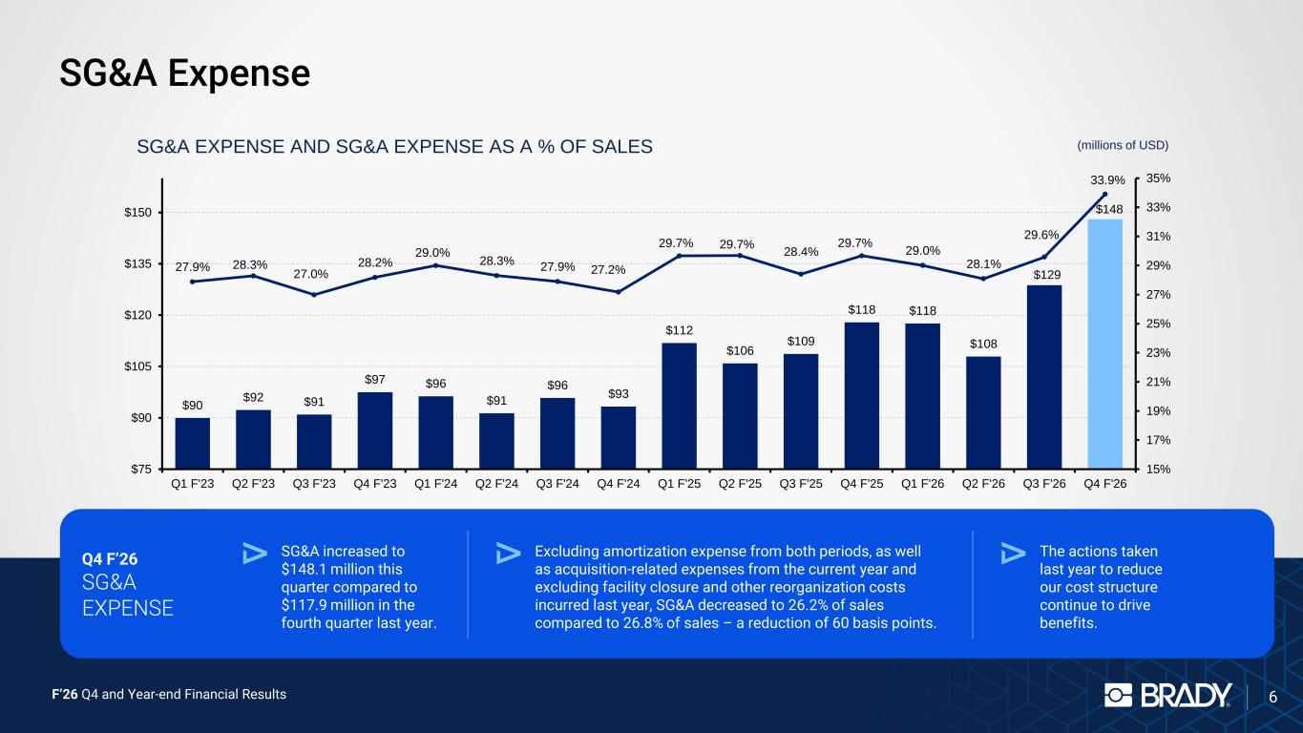
F’26 Q4 and Year-end Financial Results SG&A Expense 6 $90 $92 $91 $97 $96 $91 $96 $93 $112 $106 $109 $118 $118 $108 $129 $148 27.9% 28.3% 27.0% 28.2% 29.0% 28.3% 27.9% 27.2% 29.7% 29.7% 28.4% 29.7% 29.0% 28.1% 29.6% 33.9% 15% 17% 19% 21% 23% 25% 27% 29% 31% 33% 35% $75 $90 $105 $120 $135 $150 Q1 F'23 Q2 F'23 Q3 F'23 Q4 F'23 Q1 F'24 Q2 F'24 Q3 F'24 Q4 F'24 Q1 F'25 Q2 F'25 Q3 F'25 Q4 F'25 Q1 F'26 Q2 F'26 Q3 F'26 Q4 F'26 SG&A EXPENSE AND SG&A EXPENSE AS A % OF SALES (millions of USD) Q4 F’26 SG&A EXPENSE SG&A increased to $148.1 million this quarter compared to $117.9 million in the fourth quarter last year. Excluding amortization expense from both periods, as well as acquisition-related expenses from the current year and excluding facility closure and other reorganization costs incurred last year, SG&A decreased to 26.2% of sales compared to 26.8% of sales – a reduction of 60 basis points. The actions taken last year to reduce our cost structure continue to drive benefits.

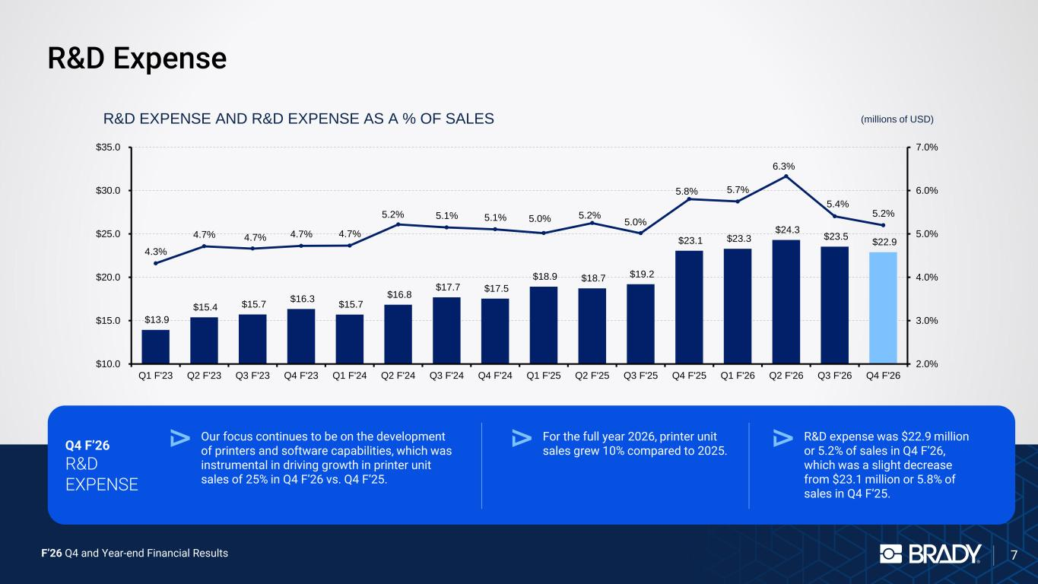
F’26 Q4 and Year-end Financial Results R&D Expense 7 $13.9 $15.4 $15.7 $16.3 $15.7 $16.8 $17.7 $17.5 $18.9 $18.7 $19.2 $23.1 $23.3 $24.3 $23.5 $22.9 4.3% 4.7% 4.7% 4.7% 4.7% 5.2% 5.1% 5.1% 5.0% 5.2% 5.0% 5.8% 5.7% 6.3% 5.4% 5.2% 2.0% 3.0% 4.0% 5.0% 6.0% 7.0% $10.0 $15.0 $20.0 $25.0 $30.0 $35.0 Q1 F'23 Q2 F'23 Q3 F'23 Q4 F'23 Q1 F'24 Q2 F'24 Q3 F'24 Q4 F'24 Q1 F'25 Q2 F'25 Q3 F'25 Q4 F'25 Q1 F'26 Q2 F'26 Q3 F'26 Q4 F'26 R&D EXPENSE AND R&D EXPENSE AS A % OF SALES (millions of USD) Q4 F’26 R&D EXPENSE Our focus continues to be on the development of printers and software capabilities, which was instrumental in driving growth in printer unit sales of 25% in Q4 F’26 vs. Q4 F’25. For the full year 2026, printer unit sales grew 10% compared to 2025. R&D expense was $22.9 million or 5.2% of sales in Q4 F’26, which was a slight decrease from $23.1 million or 5.8% of sales in Q4 F’25.

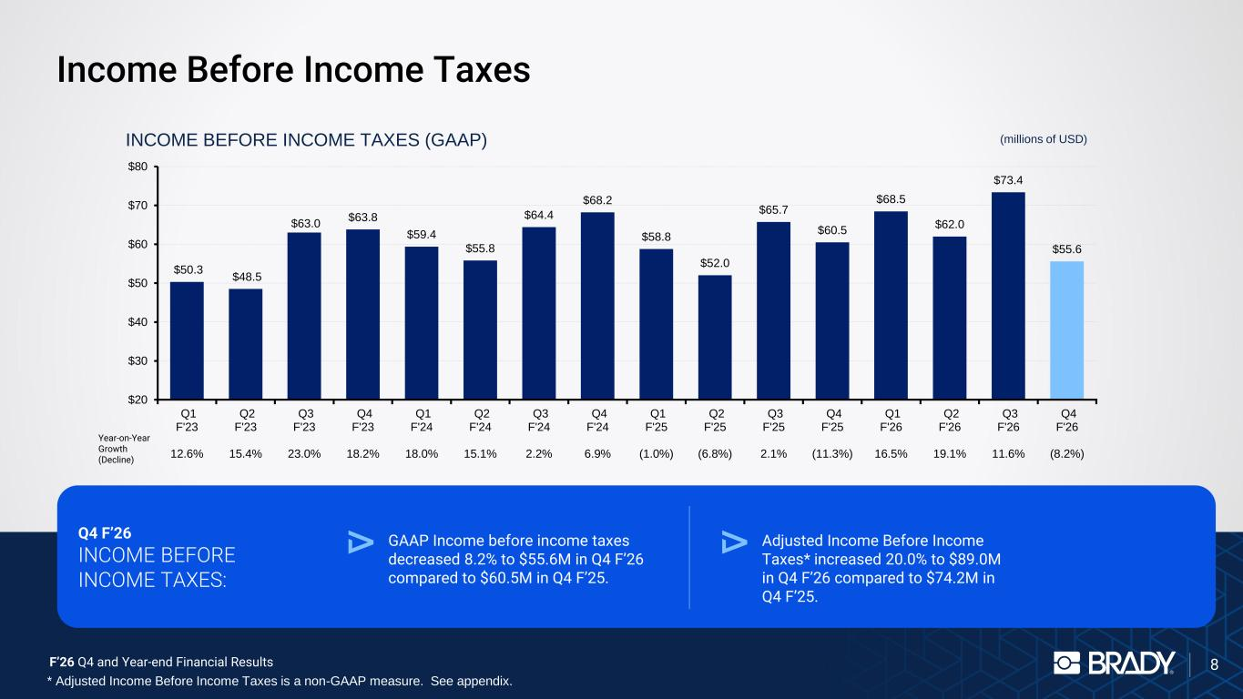
F’26 Q4 and Year-end Financial Results Income Before Income Taxes 8 $50.3 $48.5 $63.0 $63.8 $59.4 $55.8 $64.4 $68.2 $58.8 $52.0 $65.7 $60.5 $68.5 $62.0 $73.4 $55.6 $20 $30 $40 $50 $60 $70 $80 Q1 F'23 12.6% Q2 F'23 15.4% Q3 F'23 23.0% Q4 F'23 18.2% Q1 F'24 18.0% Q2 F'24 15.1% Q3 F'24 2.2% Q4 F'24 6.9% Q1 F'25 (1.0%) Q2 F'25 (6.8%) Q3 F'25 2.1% Q4 F'25 (11.3%) Q1 F'26 16.5% Q2 F'26 19.1% Q3 F'26 11.6% Q4 F'26 (8.2%) (millions of USD)INCOME BEFORE INCOME TAXES (GAAP) Year-on-Year Growth (Decline) Q4 F’26 INCOME BEFORE INCOME TAXES: GAAP Income before income taxes decreased 8.2% to $55.6M in Q4 F’26 compared to $60.5M in Q4 F’25. Adjusted Income Before Income Taxes* increased 20.0% to $89.0M in Q4 F’26 compared to $74.2M in Q4 F’25. * Adjusted Income Before Income Taxes is a non-GAAP measure. See appendix.

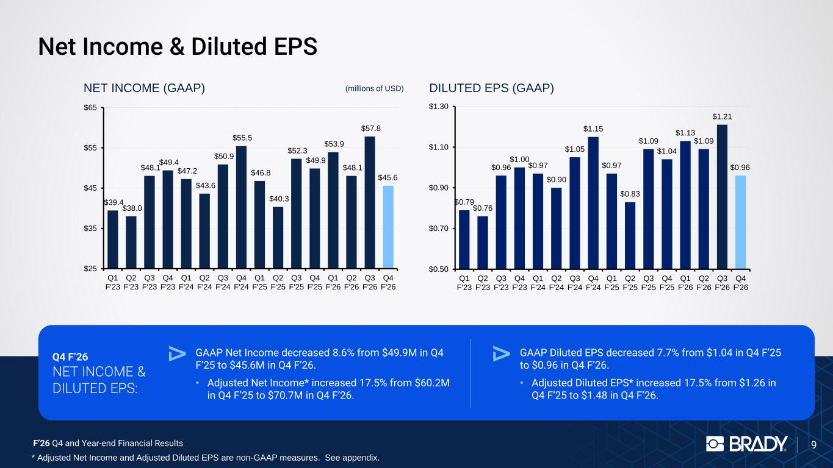
F’26 Q4 and Year-end Financial Results Net Income & Diluted EPS 9 $39.4 $38.0 $48.1 $49.4 $47.2 $43.6 $50.9 $55.5 $46.8 $40.3 $52.3 $49.9 $53.9 $48.1 $57.8 $45.6 $25 $35 $45 $55 $65 Q1 F'23 Q2 F'23 Q3 F'23 Q4 F'23 Q1 F'24 Q2 F'24 Q3 F'24 Q4 F'24 Q1 F'25 Q2 F'25 Q3 F'25 Q4 F'25 Q1 F'26 Q2 F'26 Q3 F'26 Q4 F'26 NET INCOME (GAAP) (millions of USD) $0.79 $0.76 $0.96 $1.00 $0.97 $0.90 $1.05 $1.15 $0.97 $0.83 $1.09 $1.04 $1.13 $1.09 $1.21 $0.96 $0.50 $0.70 $0.90 $1.10 $1.30 Q1 F'23 Q2 F'23 Q3 F'23 Q4 F'23 Q1 F'24 Q2 F'24 Q3 F'24 Q4 F'24 Q1 F'25 Q2 F'25 Q3 F'25 Q4 F'25 Q1 F'26 Q2 F'26 Q3 F'26 Q4 F'26 DILUTED EPS (GAAP) Q4 F’26 NET INCOME & DILUTED EPS: GAAP Net Income decreased 8.6% from $49.9M in Q4 F’25 to $45.6M in Q4 F’26. • Adjusted Net Income* increased 17.5% from $60.2M in Q4 F’25 to $70.7M in Q4 F’26. GAAP Diluted EPS decreased 7.7% from $1.04 in Q4 F’25 to $0.96 in Q4 F’26. • Adjusted Diluted EPS* increased 17.5% from $1.26 in Q4 F’25 to $1.48 in Q4 F’26. * Adjusted Net Income and Adjusted Diluted EPS are non-GAAP measures. See appendix.

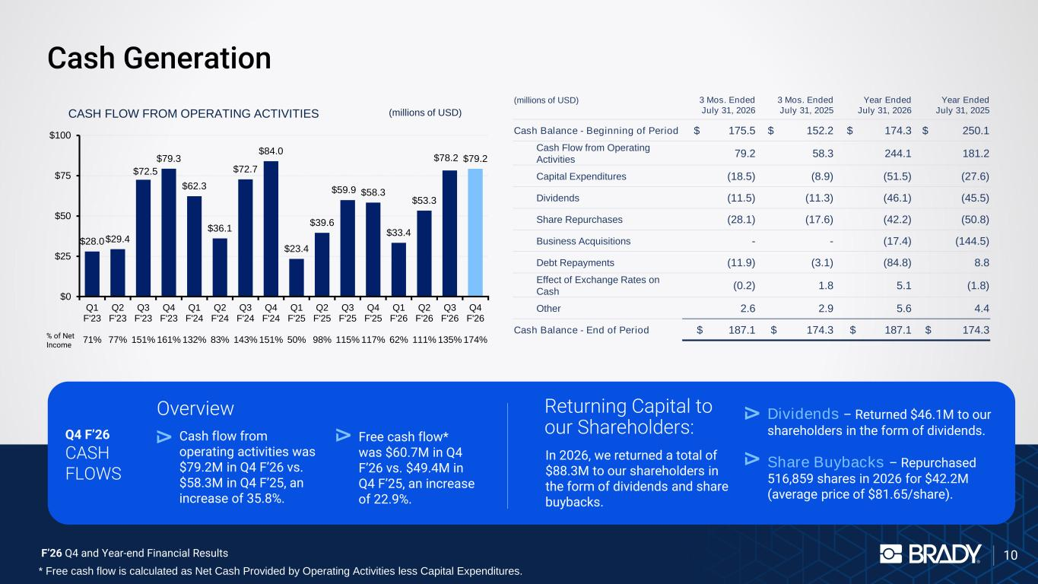
F’26 Q4 and Year-end Financial Results Cash Generation 10 Overview CASH FLOW FROM OPERATING ACTIVITIES $28.0 $29.4 $72.5 $79.3 $62.3 $36.1 $72.7 $84.0 $23.4 $39.6 $59.9 $58.3 $33.4 $53.3 $78.2 $79.2 $0 $25 $50 $75 $100 Q1 F'23 71% Q2 F'23 77% Q3 F'23 151% Q4 F'23 161% Q1 F'24 132% Q2 F'24 83% Q3 F'24 143% Q4 F'24 151% Q1 F'25 50% Q2 F'25 98% Q3 F'25 115% Q4 F'25 117% Q1 F'26 62% Q2 F'26 111% Q3 F'26 135% Q4 F'26 174% % of Net Income (millions of USD) Cash flow from operating activities was $79.2M in Q4 F’26 vs. $58.3M in Q4 F’25, an increase of 35.8%. Free cash flow* was $60.7M in Q4 F’26 vs. $49.4M in Q4 F’25, an increase of 22.9%. Returning Capital to our Shareholders: In 2026, we returned a total of $88.3M to our shareholders in the form of dividends and share buybacks. Dividends – Returned $46.1M to our shareholders in the form of dividends. Share Buybacks – Repurchased 516,859 shares in 2026 for $42.2M (average price of $81.65/share). Q4 F’26 CASH FLOWS (millions of USD) 3 Mos. Ended July 31, 2026 3 Mos. Ended July 31, 2025 Year Ended July 31, 2026 Year Ended July 31, 2025 Cash Balance - Beginning of Period $ 175.5 $ 152.2 $ 174.3 $ 250.1 Cash Flow from Operating Activities 79.2 58.3 244.1 181.2 Capital Expenditures (18.5) (8.9) (51.5) (27.6) Dividends (11.5) (11.3) (46.1) (45.5) Share Repurchases (28.1) (17.6) (42.2) (50.8) Business Acquisitions - - (17.4) (144.5) Debt Repayments (11.9) (3.1) (84.8) 8.8 Effect of Exchange Rates on Cash (0.2) 1.8 5.1 (1.8) Other 2.6 2.9 5.6 4.4 Cash Balance - End of Period $ 187.1 $ 174.3 $ 187.1 $ 174.3 * Free cash flow is calculated as Net Cash Provided by Operating Activities less Capital Expenditures.

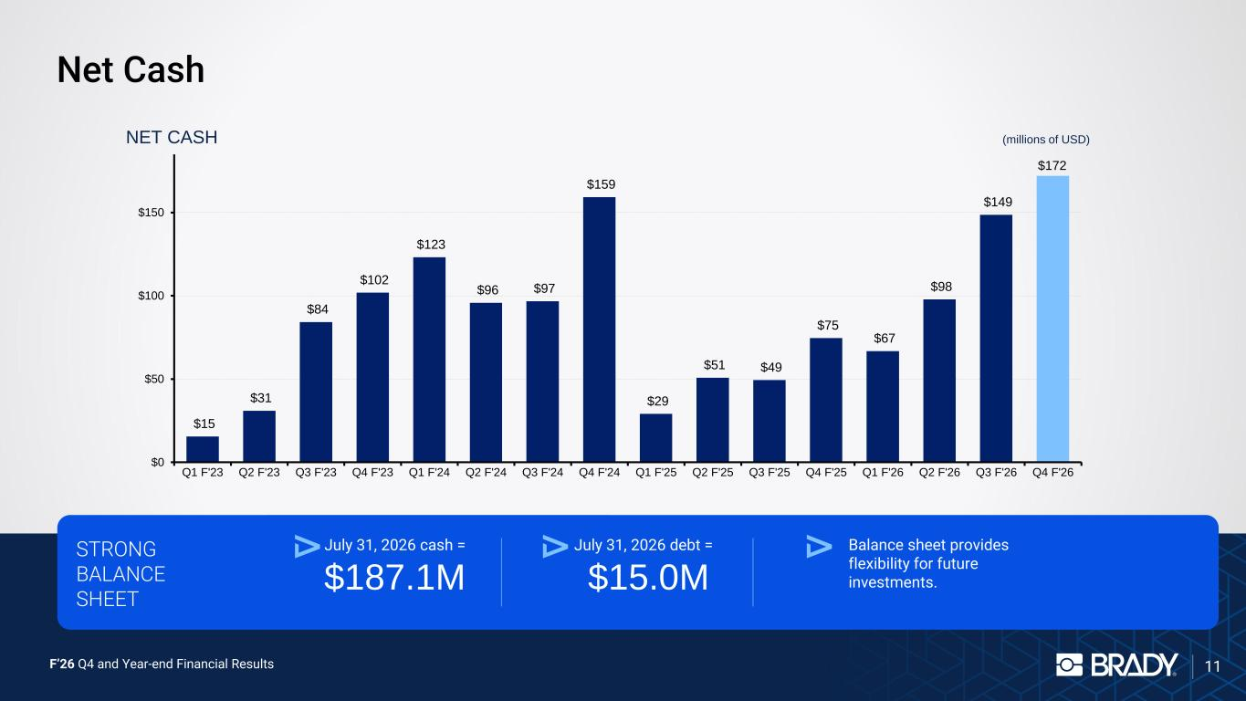
F’26 Q4 and Year-end Financial Results Net Cash 11 $15 $31 $84 $102 $123 $96 $97 $159 $29 $51 $49 $75 $67 $98 $149 $172 $0 $50 $100 $150 Q1 F'23 Q2 F'23 Q3 F'23 Q4 F'23 Q1 F'24 Q2 F'24 Q3 F'24 Q4 F'24 Q1 F'25 Q2 F'25 Q3 F'25 Q4 F'25 Q1 F'26 Q2 F'26 Q3 F'26 Q4 F'26 NET CASH STRONG BALANCE SHEET July 31, 2026 cash = $187.1M Balance sheet provides flexibility for future investments. July 31, 2026 debt = $15.0M (millions of USD)

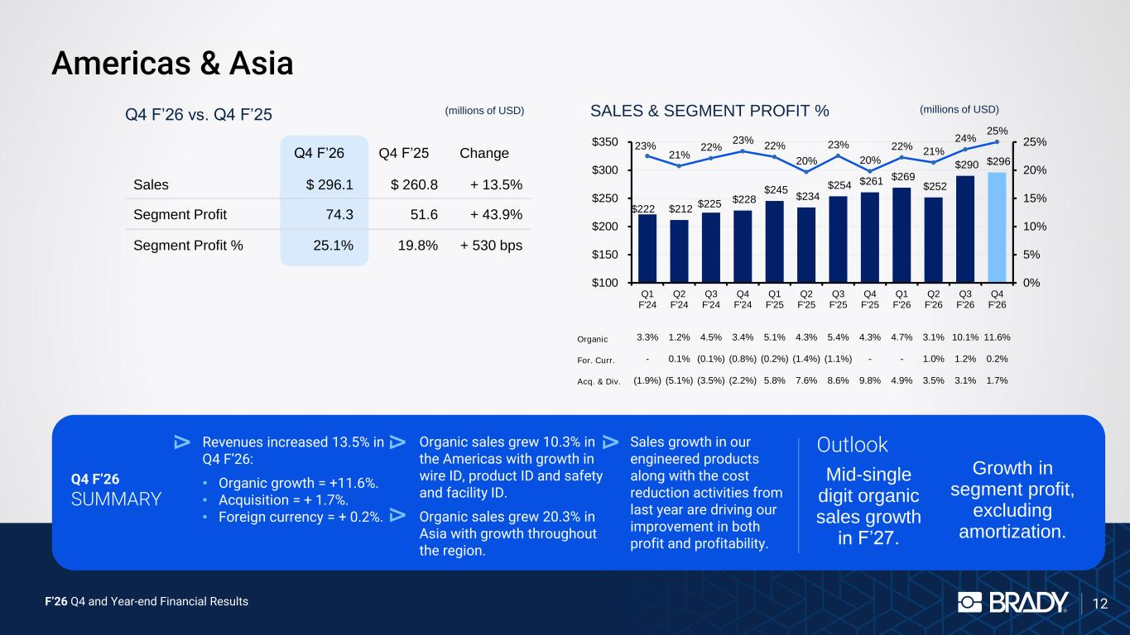
F’26 Q4 and Year-end Financial Results 12 Americas & Asia Q4 F’26 SUMMARY Revenues increased 13.5% in Q4 F’26: • Organic growth = +11.6%. • Acquisition = + 1.7%. • Foreign currency = + 0.2%. Organic sales grew 10.3% in the Americas with growth in wire ID, product ID and safety and facility ID. Organic sales grew 20.3% in Asia with growth throughout the region. Sales growth in our engineered products along with the cost reduction activities from last year are driving our improvement in both profit and profitability. Outlook Mid-single digit organic sales growth in F’27. Growth in segment profit, excluding amortization. Q4 F’26 vs. Q4 F’25 (millions of USD) $222 $212 $225 $228 $245 $234 $254 $261 $269 $252 $290 $296 23% 21% 22% 23% 22% 20% 23% 20% 22% 21% 24% 25% 0% 5% 10% 15% 20% 25% $100 $150 $200 $250 $300 $350 Q1 F'24 3.3% - (1.9%) Q2 F'24 1.2% 0.1% (5.1%) Q3 F'24 4.5% (0.1%) (3.5%) Q4 F'24 3.4% (0.8%) (2.2%) Q1 F'25 5.1% (0.2%) 5.8% Q2 F'25 4.3% (1.4%) 7.6% Q3 F'25 5.4% (1.1%) 8.6% Q4 F'25 4.3% - 9.8% Q1 F'26 4.7% - 4.9% Q2 F'26 3.1% 1.0% 3.5% Q3 F'26 10.1% 1.2% 3.1% Q4 F'26 11.6% 0.2% 1.7% SALES & SEGMENT PROFIT % (millions of USD) Q4 F’26 Q4 F’25 Change Sales $ 296.1 $ 260.8 + 13.5% Segment Profit 74.3 51.6 + 43.9% Segment Profit % 25.1% 19.8% + 530 bps Organic For. Curr. Acq. & Div.

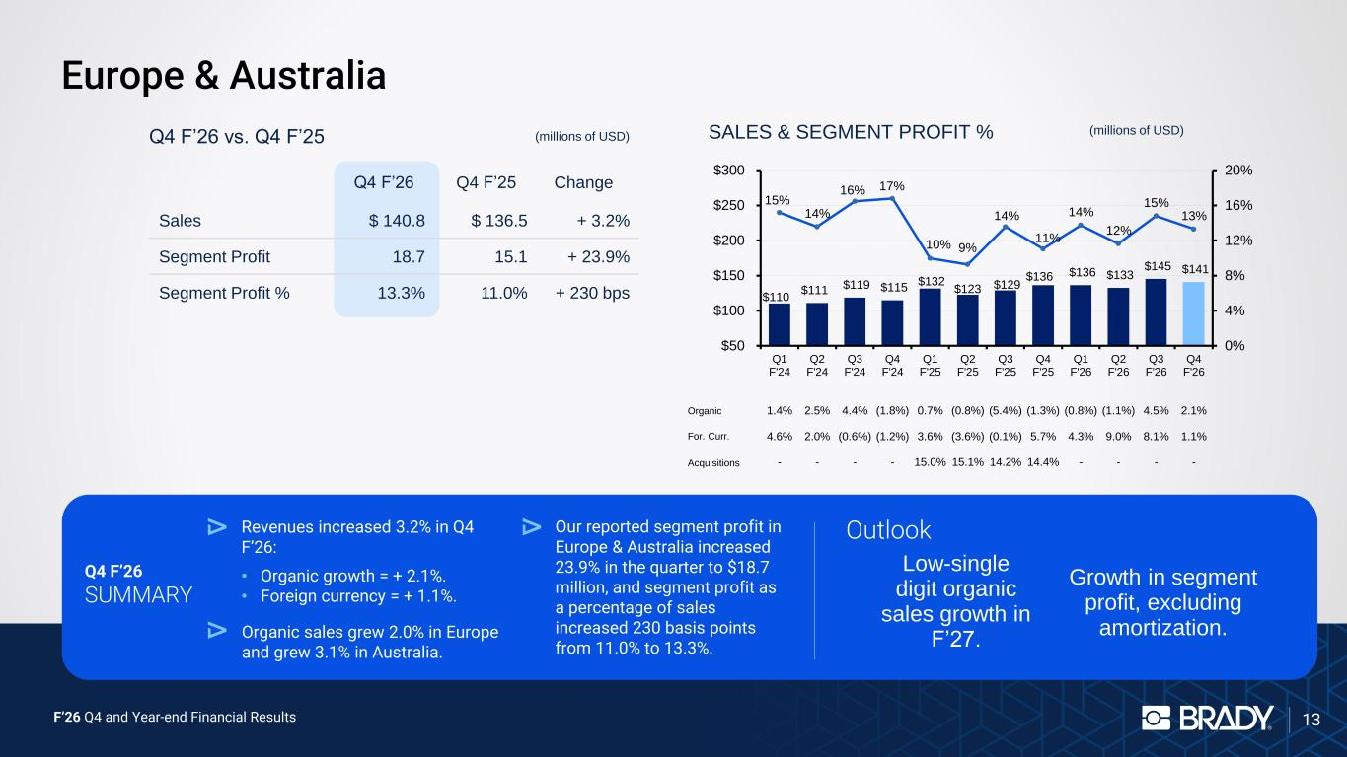
F’26 Q4 and Year-end Financial Results 13 Europe & Australia Q4 F’26 SUMMARY Revenues increased 3.2% in Q4 F’26: • Organic growth = + 2.1%. • Foreign currency = + 1.1%. Organic sales grew 2.0% in Europe and grew 3.1% in Australia. Our reported segment profit in Europe & Australia increased 23.9% in the quarter to $18.7 million, and segment profit as a percentage of sales increased 230 basis points from 11.0% to 13.3%. Outlook Q4 F’26 vs. Q4 F’25 (millions of USD) SALES & SEGMENT PROFIT % (millions of USD) Organic For. Curr. Acquisitions Q4 F’26 Q4 F’25 Change Sales $ 140.8 $ 136.5 + 3.2% Segment Profit 18.7 15.1 + 23.9% Segment Profit % 13.3% 11.0% + 230 bps $110 $111 $119 $115 $132 $123 $129 $136 $136 $133 $145 $141 15% 14% 16% 17% 10% 9% 14% 11% 14% 12% 15% 13% 0% 4% 8% 12% 16% 20% $50 $100 $150 $200 $250 $300 Q1 F'24 1.4% 4.6% - Q2 F'24 2.5% 2.0% - Q3 F'24 4.4% (0.6%) - Q4 F'24 (1.8%) (1.2%) - Q1 F'25 0.7% 3.6% 15.0% Q2 F'25 (0.8%) (3.6%) 15.1% Q3 F'25 (5.4%) (0.1%) 14.2% Q4 F'25 (1.3%) 5.7% 14.4% Q1 F'26 (0.8%) 4.3% - Q2 F'26 (1.1%) 9.0% - Q3 F'26 4.5% 8.1% - Q4 F'26 2.1% 1.1% - Low-single digit organic sales growth in F’27. Growth in segment profit, excluding amortization.

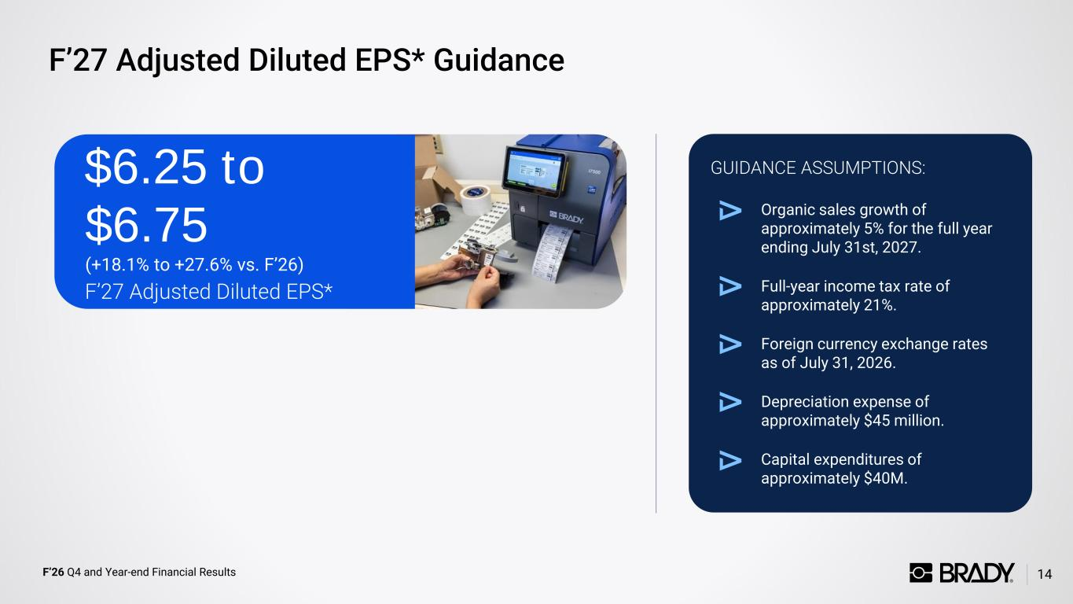
F’26 Q4 and Year-end Financial Results F’27 Adjusted Diluted EPS* Guidance 14 Organic sales growth of approximately 5% for the full year ending July 31st, 2027. Full-year income tax rate of approximately 21%. Foreign currency exchange rates as of July 31, 2026. Depreciation expense of approximately $45 million. Capital expenditures of approximately $40M. GUIDANCE ASSUMPTIONS: F’27 Adjusted Diluted EPS* $6.25 to $6.75 (+18.1% to +27.6% vs. F’26)


F’26 Q4 and Year-end Financial Results Investor Relations 15 Brady Contact: Ann Thornton Investor Relations 414-438-6887 investor@bradycorp.com See our website at www.bradycorp.com/investors


F’26 Q4 and Year-end Financial Results 16 GAAP to Non-GAAP Reconciliations Appendix Need updated reconciliations

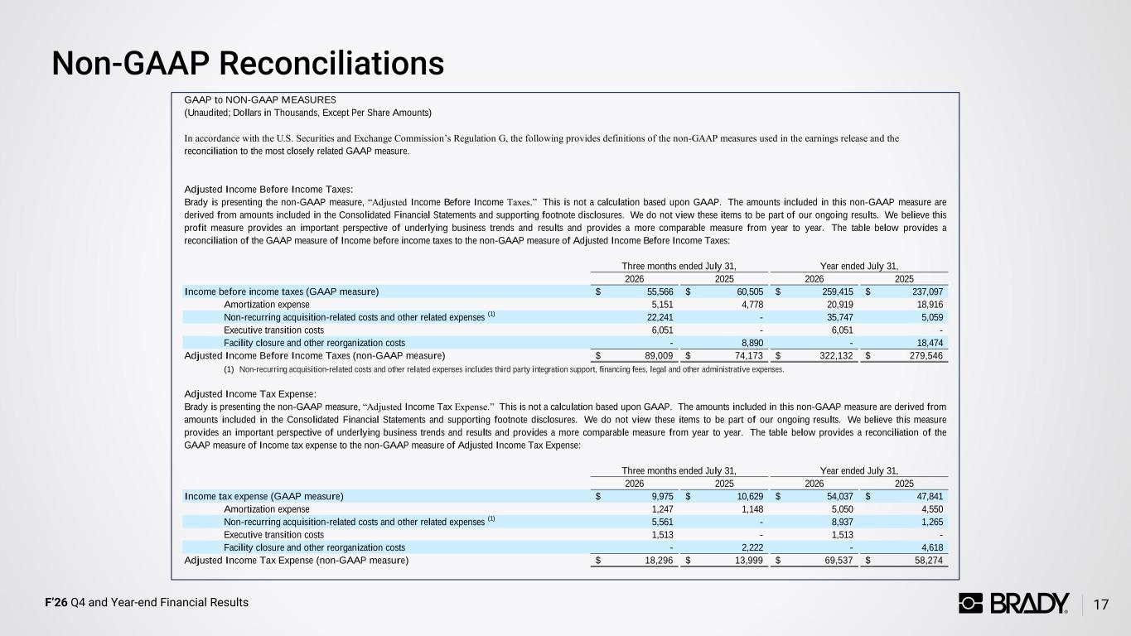
F’26 Q4 and Year-end Financial Results Non-GAAP Reconciliations 17 2026 2025 2026 2025 55,566$ 60,505$ 259,415$ 237,097$ Amortization expense 5,151 4,778 20,919 18,916 Non-recurring acquisition-related costs and other related expenses (1) 22,241 - 35,747 5,059 Executive transition costs 6,051 - 6,051 - Facility closure and other reorganization costs - 8,890 - 18,474 89,009$ 74,173$ 322,132$ 279,546$ (1) Non-recurring acquisition-related costs and other related expenses includes third party integration support, financing fees, legal and other administrative expenses. 2026 2025 2026 2025 9,975$ 10,629$ 54,037$ 47,841$ Amortization expense 1,247 1,148 5,050 4,550 Non-recurring acquisition-related costs and other related expenses (1) 5,561 - 8,937 1,265 Executive transition costs 1,513 - 1,513 - Facility closure and other reorganization costs - 2,222 - 4,618 18,296$ 13,999$ 69,537$ 58,274$ Three months ended July 31, Three months ended July 31, Adjusted Income Tax Expense (non-GAAP measure) Year ended July 31, Income before income taxes (GAAP measure) Adjusted Income Before Income Taxes (non-GAAP measure) Brady is presenting the non-GAAP measure, “Adjusted Income Tax Expense.” This is not a calculation based upon GAAP. The amounts included in this non-GAAP measure are derived from amounts included in the Consolidated Financial Statements and supporting footnote disclosures. We do not view these items to be part of our ongoing results. We believe this measure provides an important perspective of underlying business trends and results and provides a more comparable measure from year to year. The table below provides a reconciliation of the GAAP measure of Income tax expense to the non-GAAP measure of Adjusted Income Tax Expense: Year ended July 31, Income tax expense (GAAP measure) Adjusted Income Tax Expense: GAAP to NON-GAAP MEASURES (Unaudited; Dollars in Thousands, Except Per Share Amounts) In accordance with the U.S. Securities and Exchange Commission’s Regulation G, the following provides definitions of the non-GAAP measures used in the earnings release and the reconciliation to the most closely related GAAP measure. Adjusted Income Before Income Taxes: Brady is presenting the non-GAAP measure, “Adjusted Income Before Income Taxes.” This is not a calculation based upon GAAP. The amounts included in this non-GAAP measure are derived from amounts included in the Consolidated Financial Statements and supporting footnote disclosures. We do not view these items to be part of our ongoing results. We believe this profit measure provides an important perspective of underlying business trends and results and provides a more comparable measure from year to year. The table below provides a reconciliation of the GAAP measure of Income before income taxes to the non-GAAP measure of Adjusted Income Before Income Taxes:

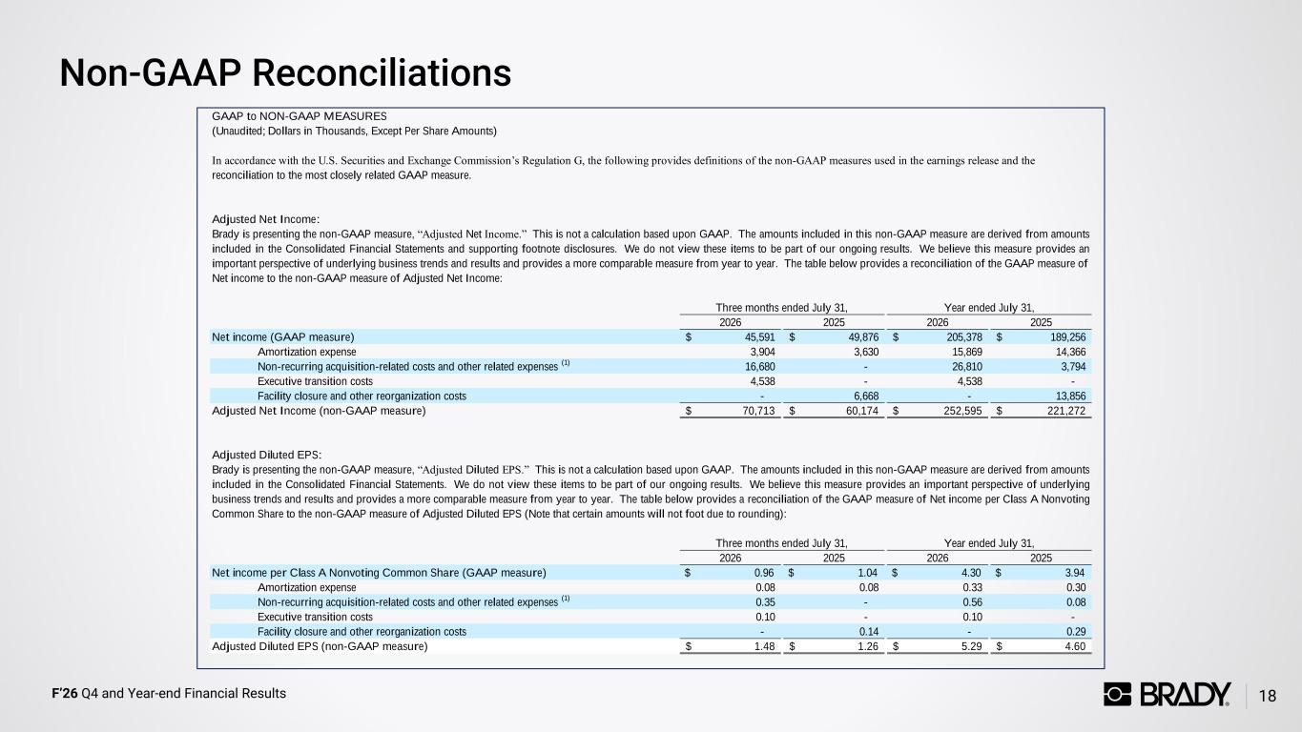
F’26 Q4 and Year-end Financial Results Non-GAAP Reconciliations 18 2026 2025 2026 2025 45,591$ 49,876$ 205,378$ 189,256$ Amortization expense 3,904 3,630 15,869 14,366 Non-recurring acquisition-related costs and other related expenses (1) 16,680 - 26,810 3,794 Executive transition costs 4,538 - 4,538 - Facility closure and other reorganization costs - 6,668 - 13,856 70,713$ 60,174$ 252,595$ 221,272$ 2026 2025 2026 2025 $ 0.96 $ 1.04 $ 4.30 $ 3.94 Amortization expense 0.08 0.08 0.33 0.30 Non-recurring acquisition-related costs and other related expenses (1) 0.35 - 0.56 0.08 Executive transition costs 0.10 - 0.10 - Facility closure and other reorganization costs - 0.14 - 0.29 1.48$ 1.26$ 5.29$ 4.60$ Adjusted Diluted EPS (non-GAAP measure) Three months ended July 31, Brady is presenting the non-GAAP measure, “Adjusted Net Income.” This is not a calculation based upon GAAP. The amounts included in this non-GAAP measure are derived from amounts included in the Consolidated Financial Statements and supporting footnote disclosures. We do not view these items to be part of our ongoing results. We believe this measure provides an important perspective of underlying business trends and results and provides a more comparable measure from year to year. The table below provides a reconciliation of the GAAP measure of Net income to the non-GAAP measure of Adjusted Net Income: Year ended July 31, Net income (GAAP measure) Adjusted Net Income (non-GAAP measure) GAAP to NON-GAAP MEASURES (Unaudited; Dollars in Thousands, Except Per Share Amounts) In accordance with the U.S. Securities and Exchange Commission’s Regulation G, the following provides definitions of the non-GAAP measures used in the earnings release and the reconciliation to the most closely related GAAP measure. Adjusted Net Income: Three months ended July 31, Brady is presenting the non-GAAP measure, “Adjusted Diluted EPS.” This is not a calculation based upon GAAP. The amounts included in this non-GAAP measure are derived from amounts included in the Consolidated Financial Statements. We do not view these items to be part of our ongoing results. We believe this measure provides an important perspective of underlying business trends and results and provides a more comparable measure from year to year. The table below provides a reconciliation of the GAAP measure of Net income per Class A Nonvoting Common Share to the non-GAAP measure of Adjusted Diluted EPS (Note that certain amounts will not foot due to rounding): Year ended July 31, Net income per Class A Nonvoting Common Share (GAAP measure) Adjusted Diluted EPS:

